PaperCity, Glassell Benefit and Auction
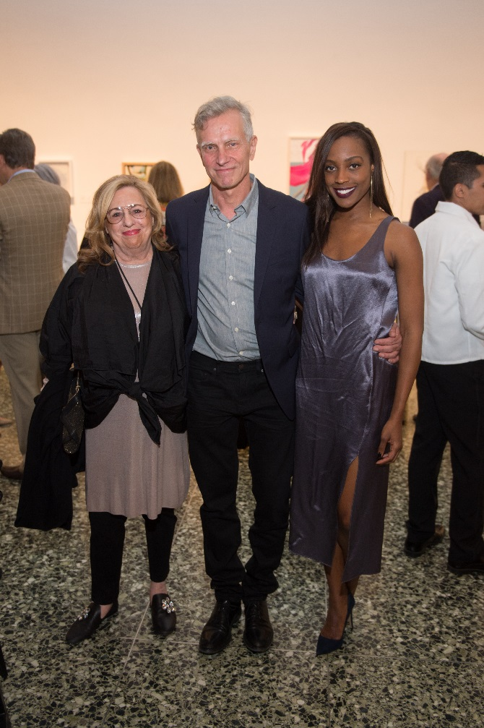
Barbara Davis; Joe Havel; Alecia Harris; Photo by Wilson Parish
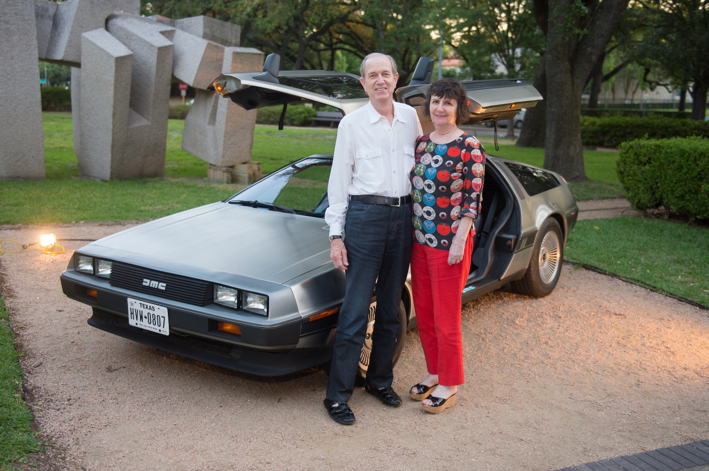
Brad and Leslie Bucher; Photo by Wilson Parish
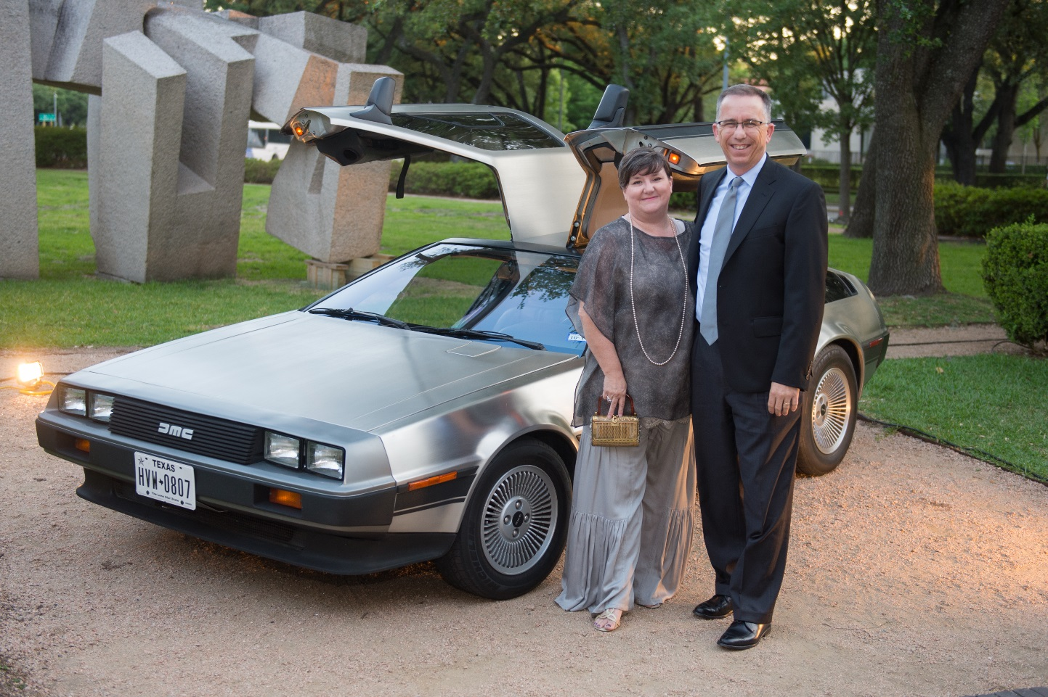
Ellen and Andy Ray; Photo by Wilson Parish
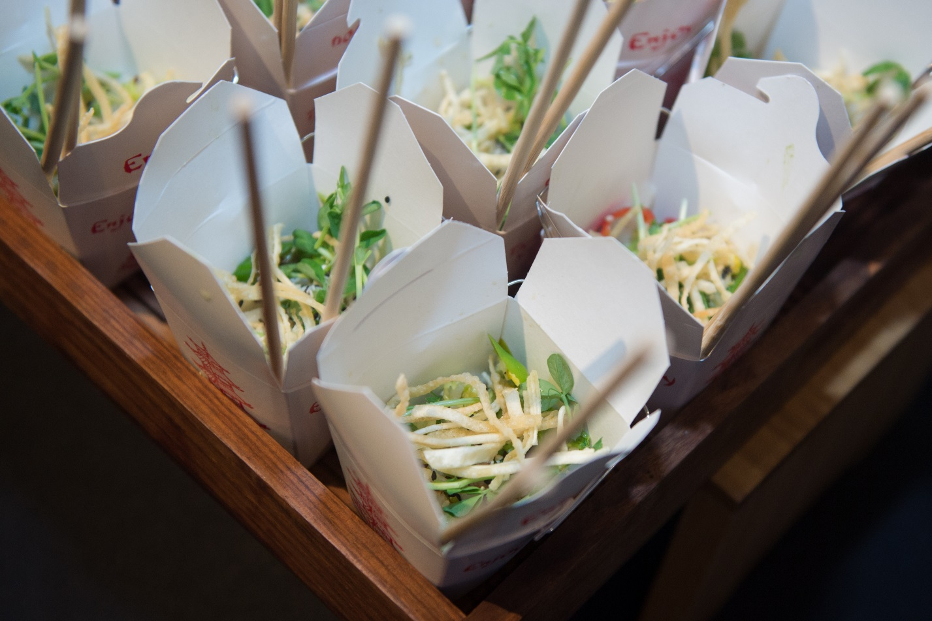
Glassell Benefit and Auction 2017_Atmopshere; Photo by Wilson Parish
Glassell Benefit and Auction 2017_Atmosphere; Photo by Wilson Parish
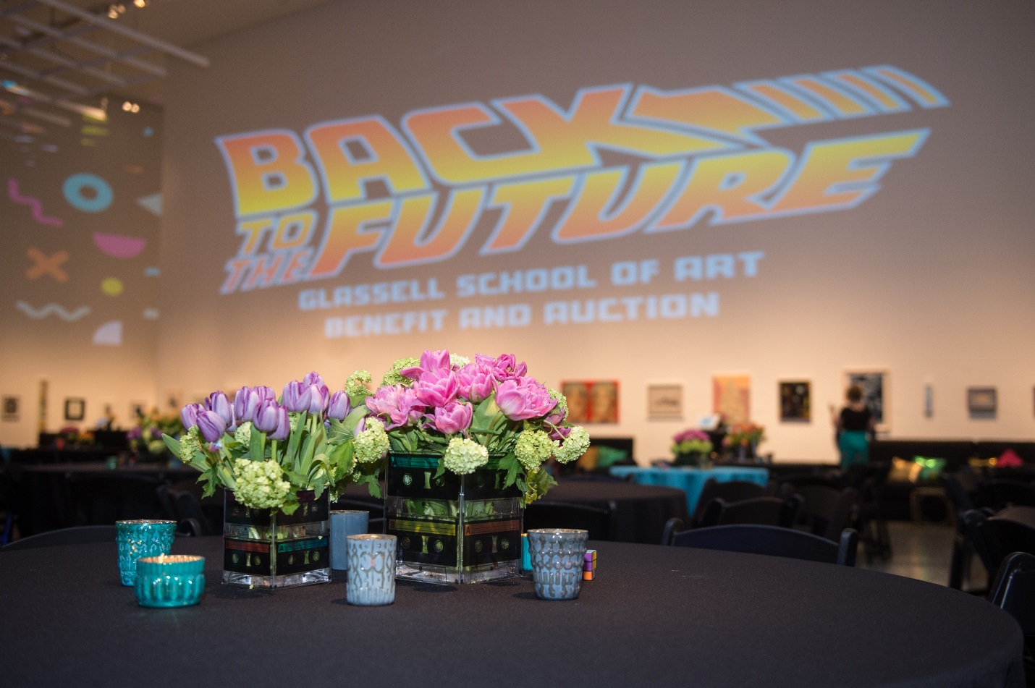
Glassell Benefit and Auction 2017_Decor; Photo by Wilson Parish
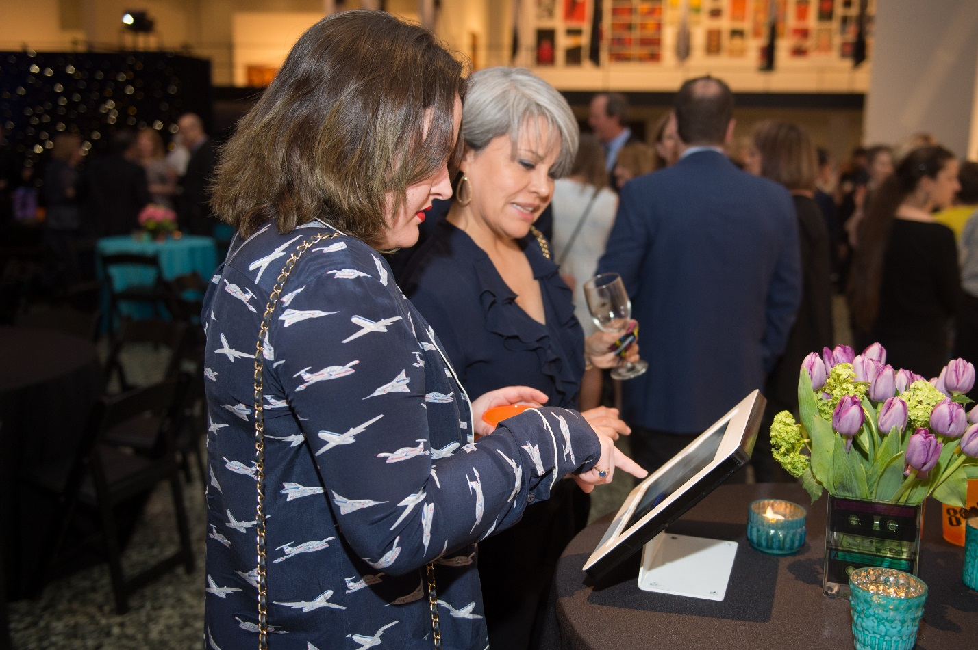
Glassell Benefit and Auction 2017_Silent Auction; Photo by Wilson Parish
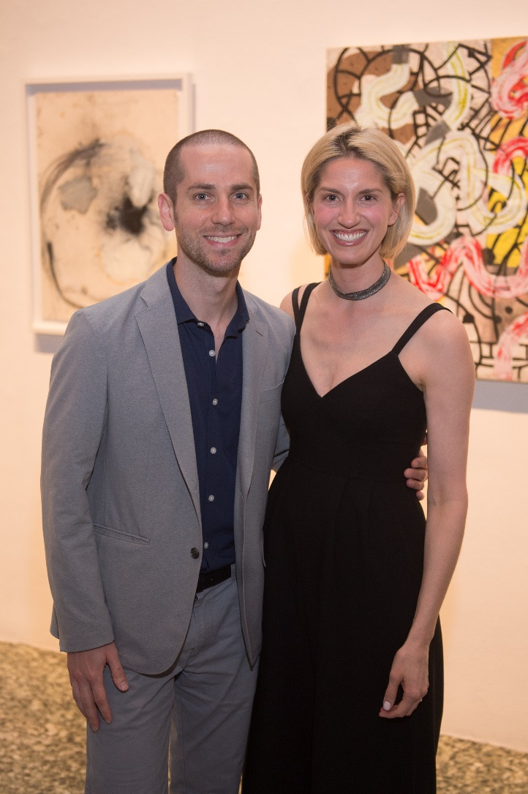
Josh Pazda and Chris Goins; Photo by Wilson Parish
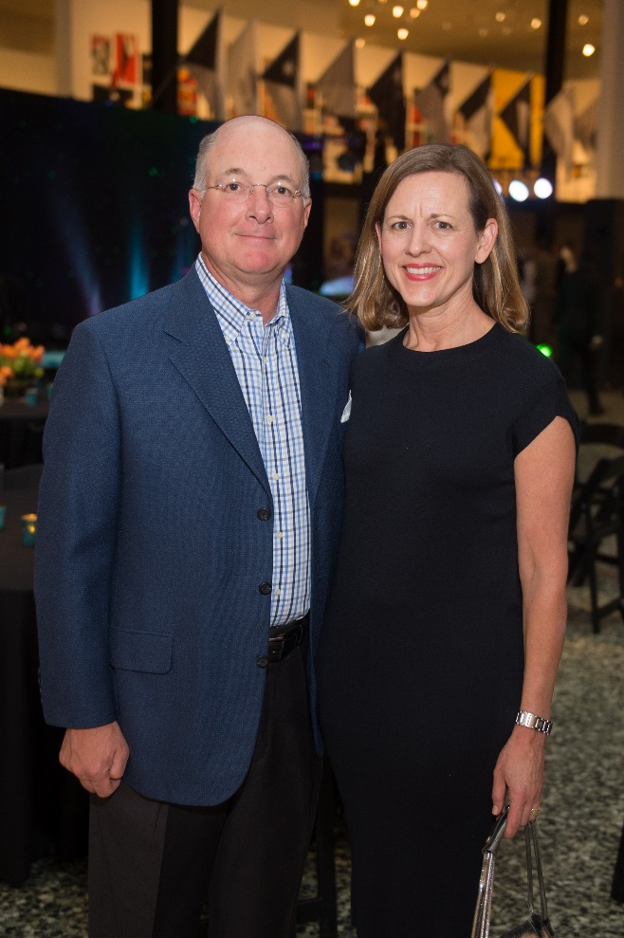
Ken and Sarah Fisher; Photo by Wilson Parish
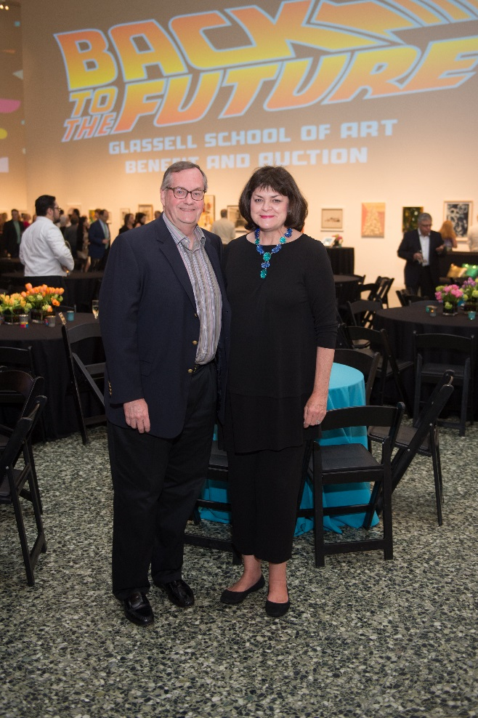
Larry and Cindy Burns; Photo by Wilson Parish
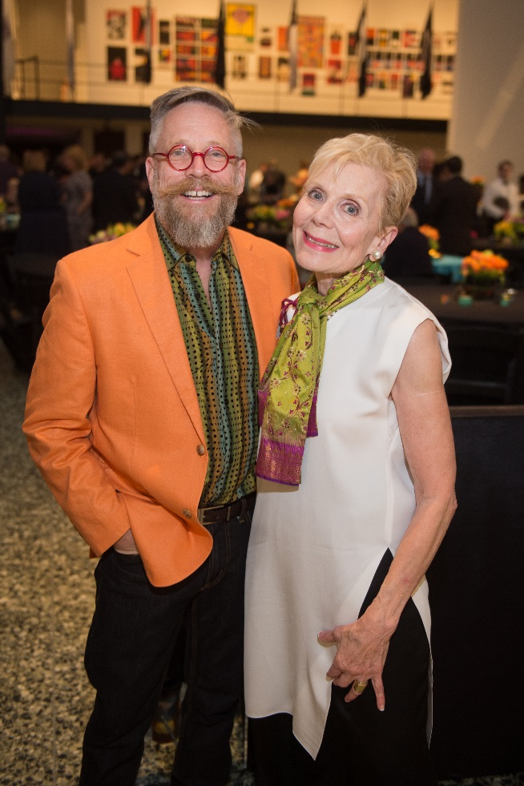
Edward Lane McCartney; Nancy Bell; Photo by Wilson Parish
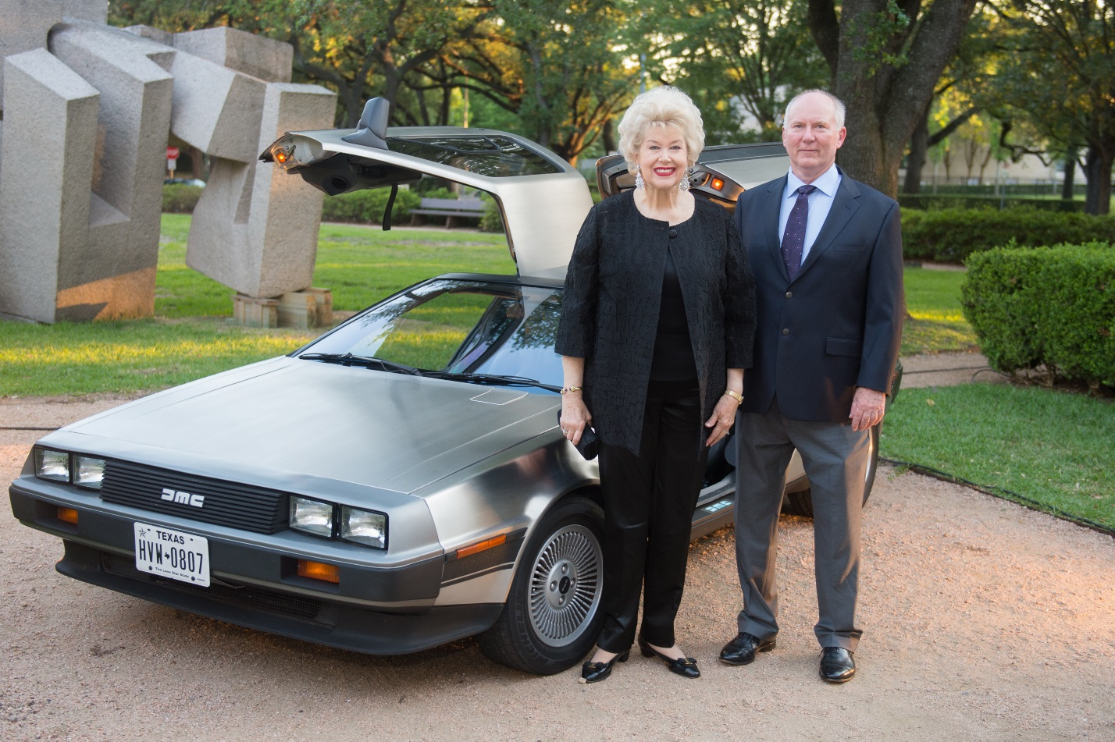
Lucy and George Sharkey; Photo by Wilson Parish
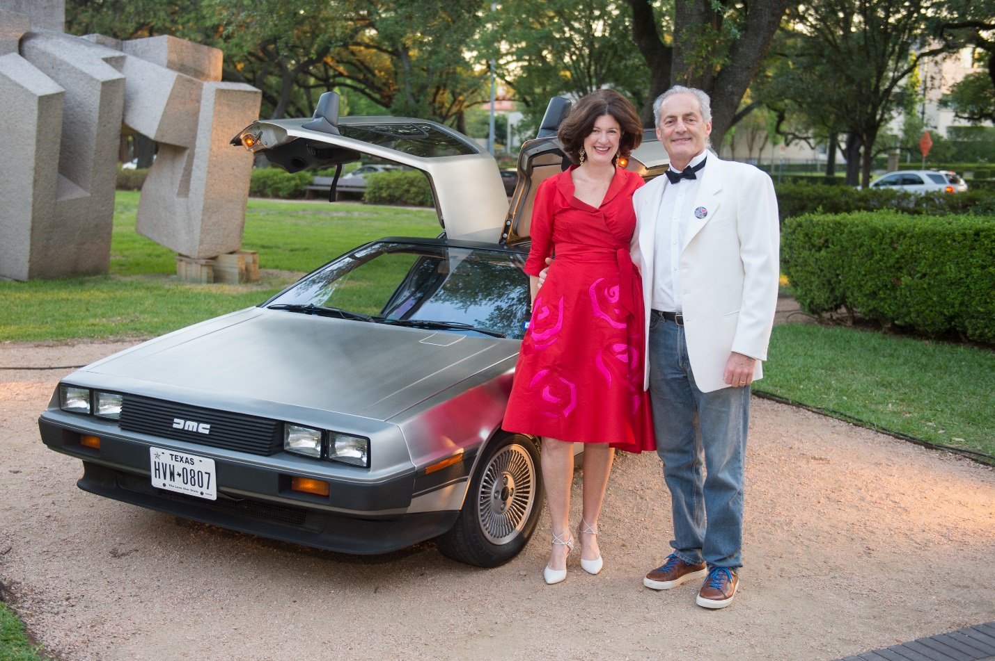
Nicola and Richard Toubia; Photo by Wilson Parish
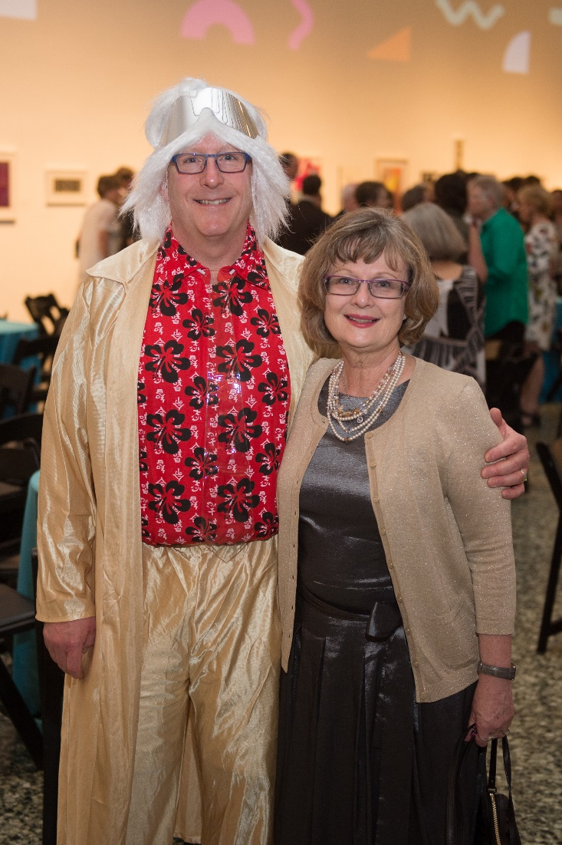
Richard Stang; Kimberly Watson; Photo by Wilson Parish
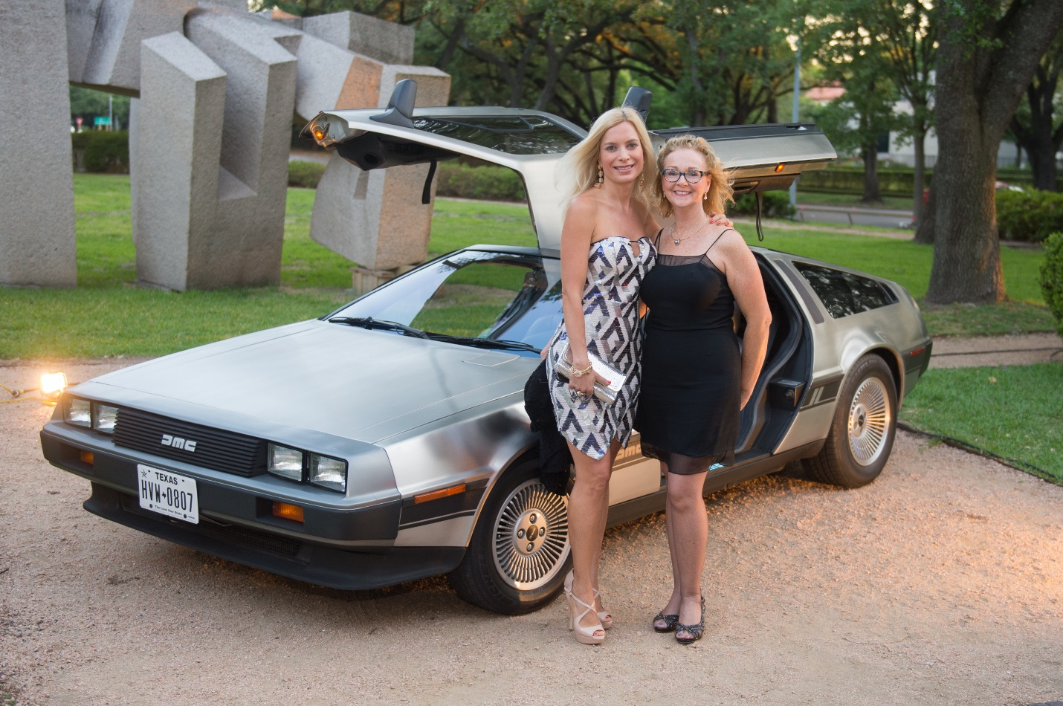
Roberta March; Debra DeSaulniers; Photo by Wilson Parish
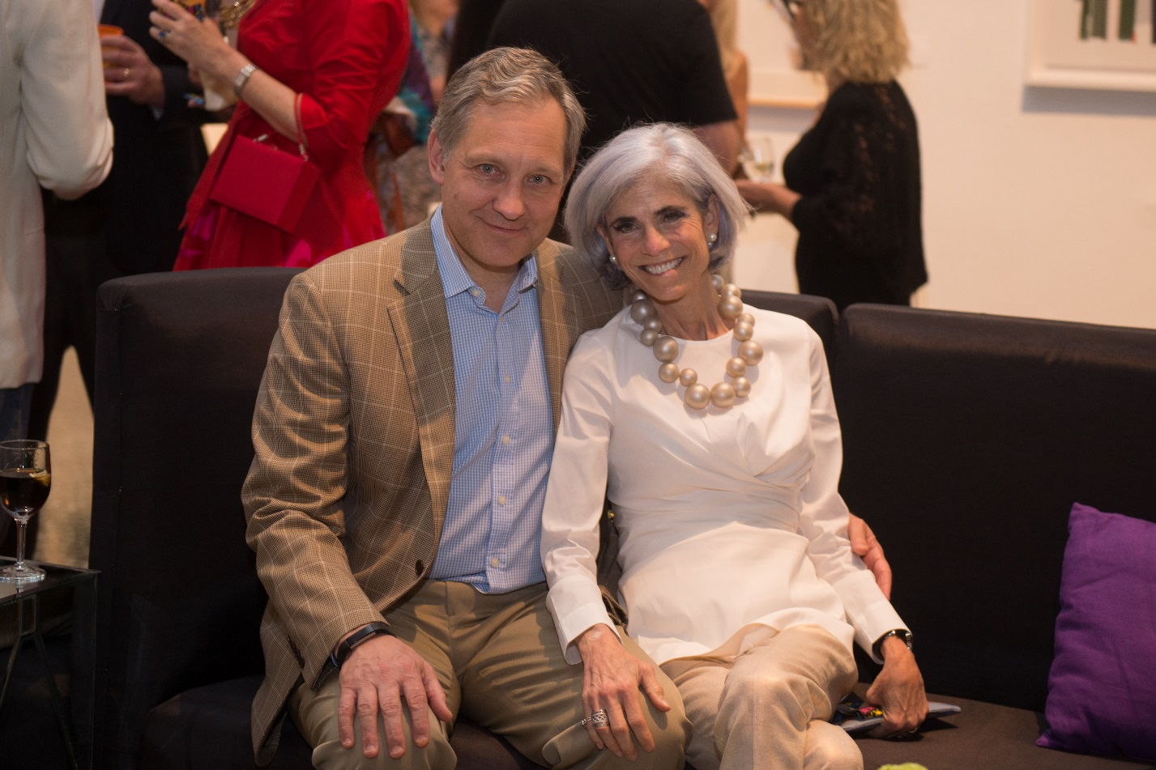
Scott and Judy Nyquist; Photo by Wilson Parish
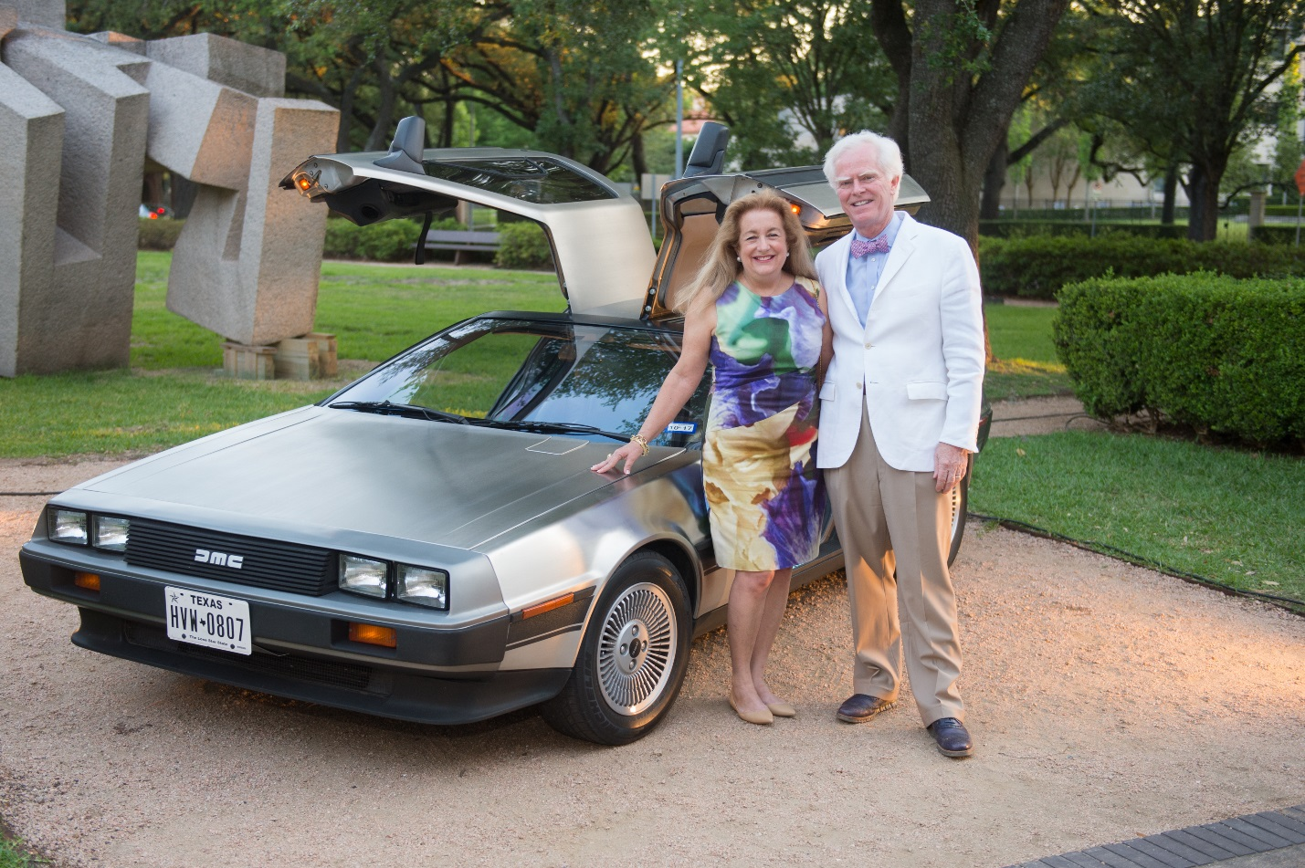
Yvonne and Scott Ziegler; Photo by Wilson Parish

