PaperCity; The Glamour and Romance of Oscar de la Renta Opening Dinner Caption Sheet
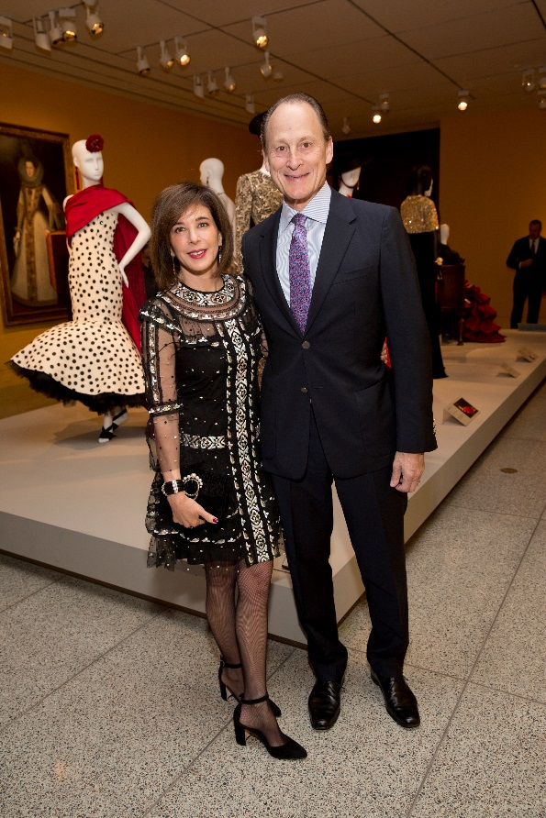
Barbara and Michael Gamson; Photo by Jenny Antill
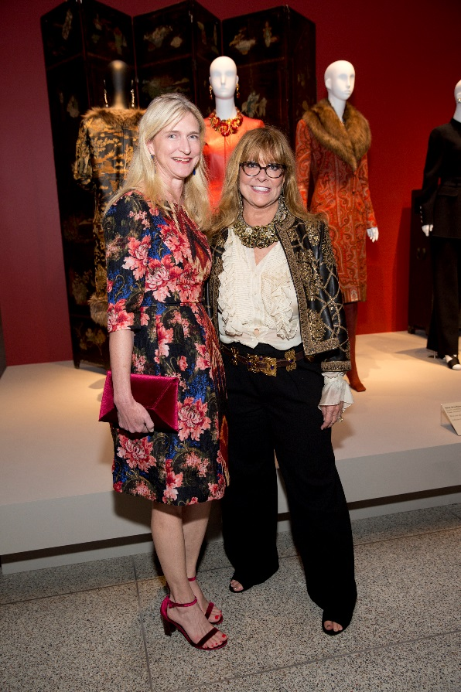
Carroll Goodman; Meg Goodman; Photo by Jenny Antill

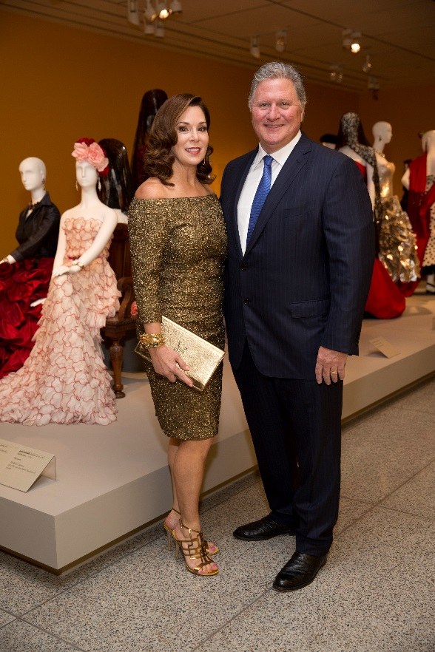
Cherie and Jim Flores; Photo by Jenny Antill
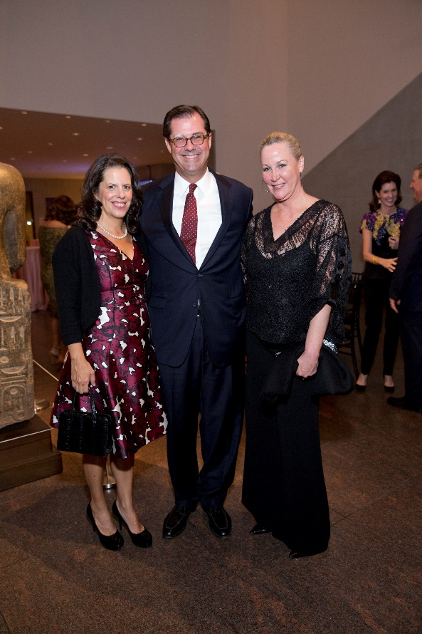
Isabel and Ransom Lummis; Sara Paschall Dodd; Photo by Jenny Antill
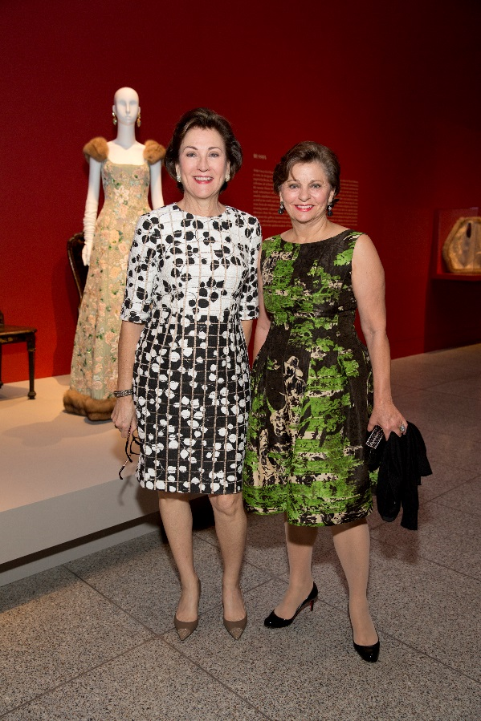
Kelly Samosa; Beth Madison; Photo by Jenny Antill
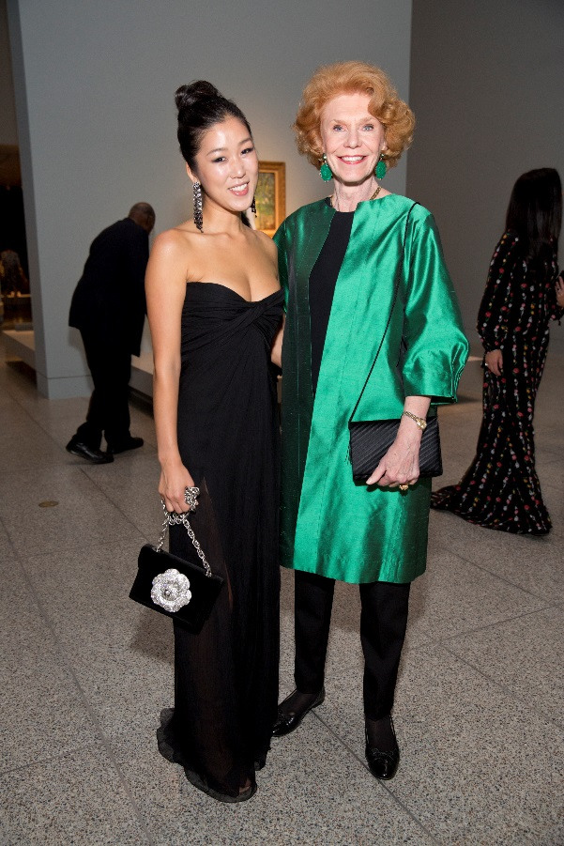
Laura Kim and Patricia Jefferies; Photo by Jenny Antill
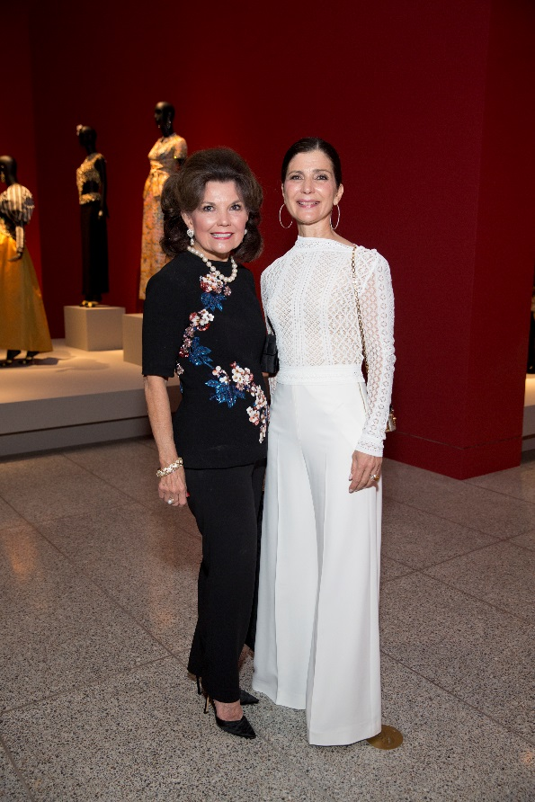
Linda McReynolds; Cynthia Petrello; Photo by Jenny Antill
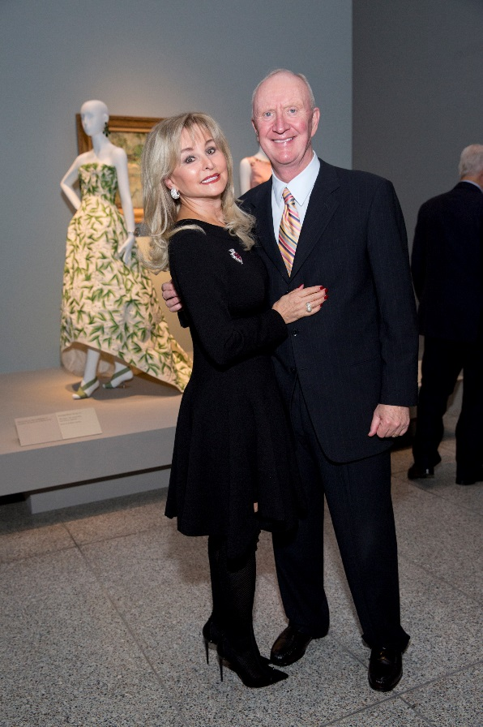
Michelle and Frank Hevrdejs; Photo by Jenny Antill
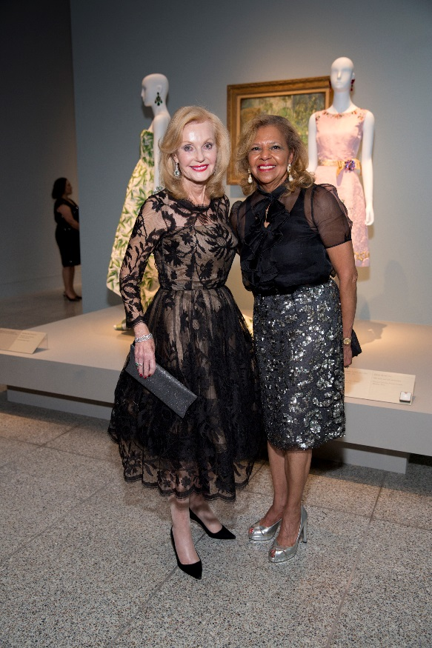
Pat Breen; Yvonne Cormier; Photo by Jenny Antill
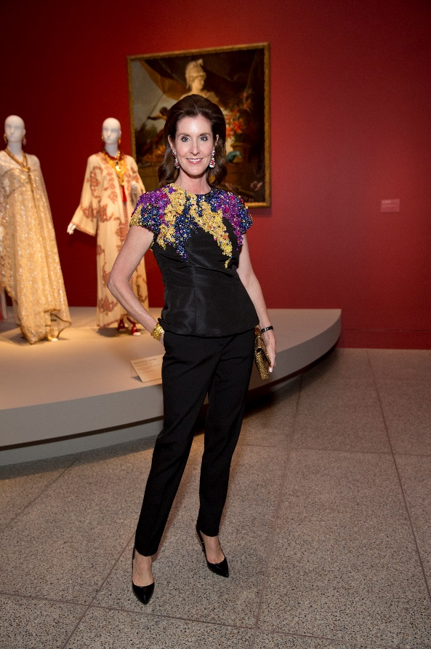
Phoebe Tudor; Photo by Jenny Antill
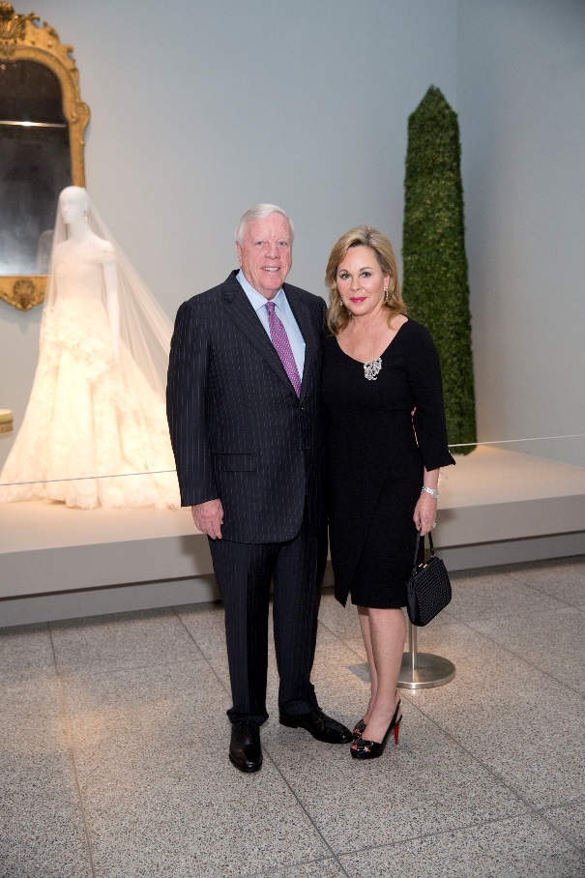
Rich and Nancy Kinder; Photo by Jenny Antill
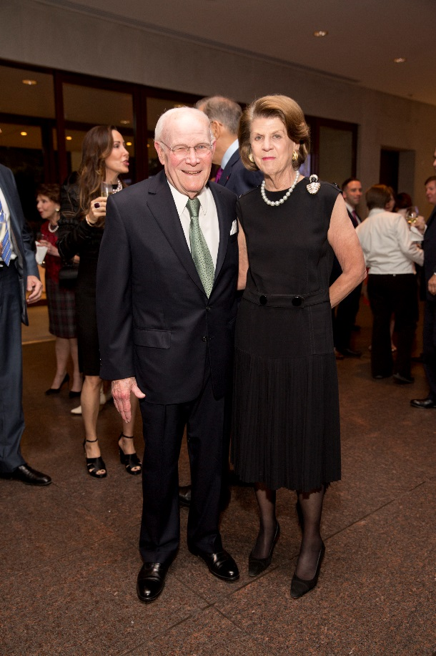
Rodney and Judy Margolis; Photo by Jenny Antill

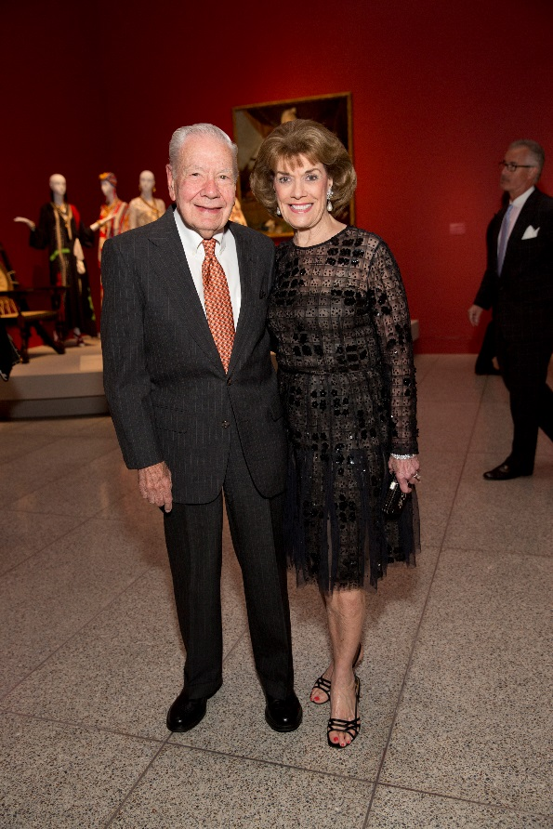
Wally Wilson and Jeanie Kilroy Wilson; Photo by Jenny Antill
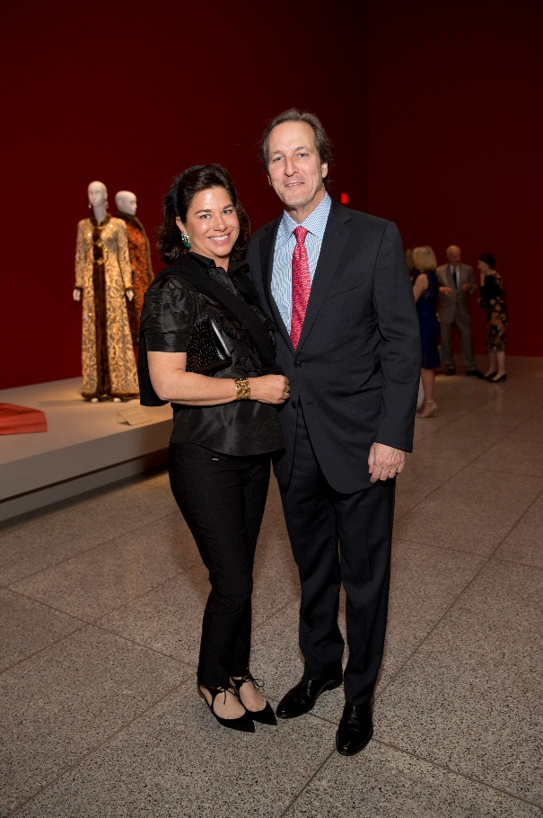
Windi and David Grimes; Photo by Jenny Antill

