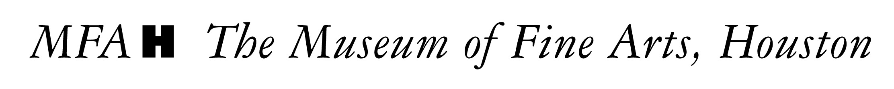

WHAT Rienzi Spring Party 2017

WHEN Wednesday, April 19, 2017, from 7:30 to 10 p.m.

WHERE Rienzi, 1406 Kirby

CHAIRMEN Stacey and Jeff Henningsen; Rachel and Mark Lawrence;
and Angie and John Reckling.

DETAILS On Wednesday evening, nearly 320 guests flocked to Rienzi for the annual Rienzi Spring Party. The event’s theme was a Mexican Fiesta, highlighting the Mexican Room at the MFAH house museum. Guests entered underneath white Mexican banners lining the driveway leading to Rienzi, where they were greeted with a Mariachi band and waiters serving the signature cocktails-palomas and margaritas.

The décor and menu by Swift & Co. included tables adorned with black and melon linens and centerpieces of orange roses, fuchsia anemones, red gerbera daisies, and blue hydrangeas. The menu of passed hors d’oeuvres followed by a buffet featured beef empanadas, squash blossom quesadillas, jalapeno quail and pecan-smoked bacon en brochette, southwestern salad, cheese enchiladas, tacos, and roasted fresh corn. Guests gathered outside, enjoying poolside cocktails. The 2017 event raised a total of $152,000 for Rienzi’s operating budget.

GUESTS Jerry Ann Woodfin-Costa and Victor Costa; Lynda Underwood; Kathy and John Stanton; Ann Trammell; Stacey and Jeff Henningsen; Rachel and Mark Lawrence; Catherine and Cenk Ozdogan; Angie and John Reckling; Christiana McConn; Isla and Tommy Reckling; Isla and Joseph Jornayvaz; Sheila and Jerry Reese; Pam and David Ott; Stacy and Michael Ellington; Carroll Goodman; Cathy and Joe Cleary; Joy and Edward Randall; Eleni and Thad Fuller; Kathy and Marty Goossen; and Elise and James Reckling.

PHOTOGRAPHER Jenny Antill

