PaperCity; Rienzi Spring Party 2017
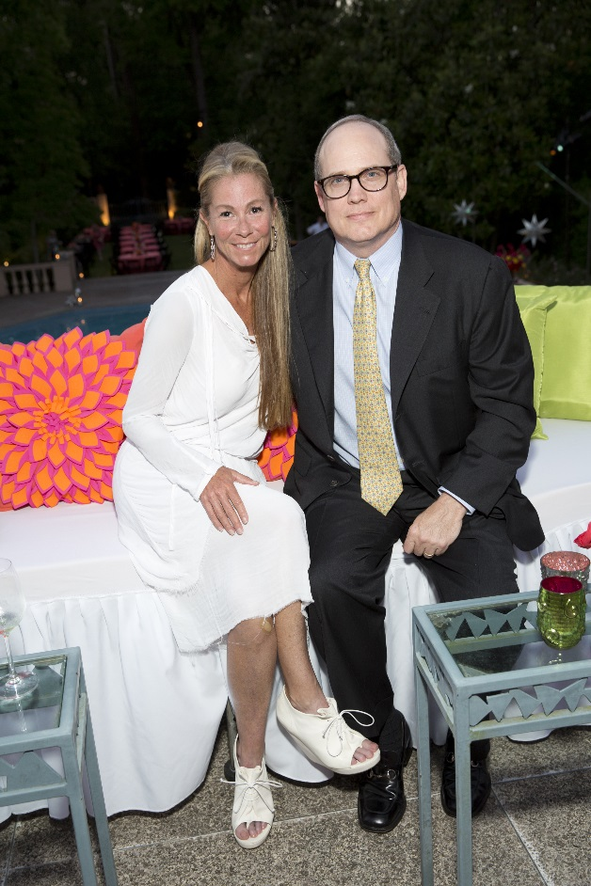
Ann and Michael Wilde; Photo by Jenny Antill
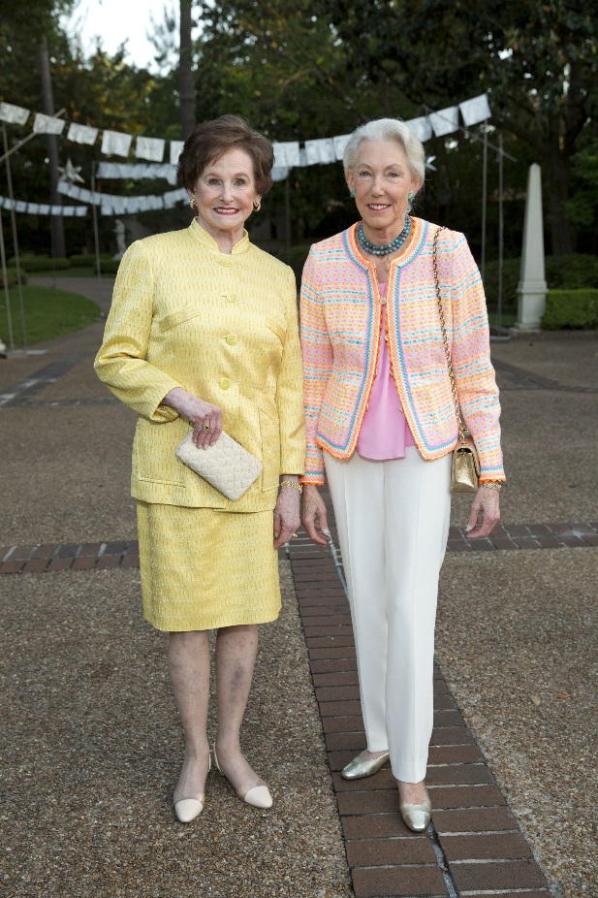
Ann Trammell; Lynda Underwood; Photo by Jenny Antill
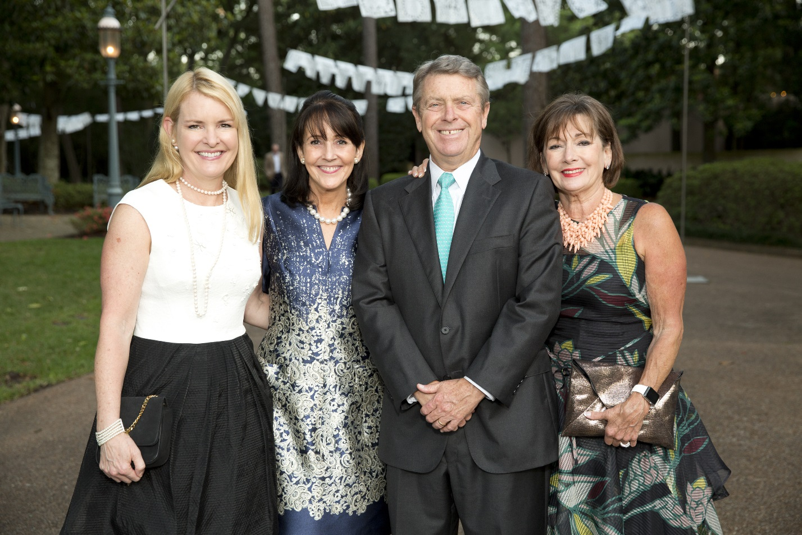
Anne Hamman; Jenny Elkins; Joe and Cathy Cleary; Photo by Jenny Antill
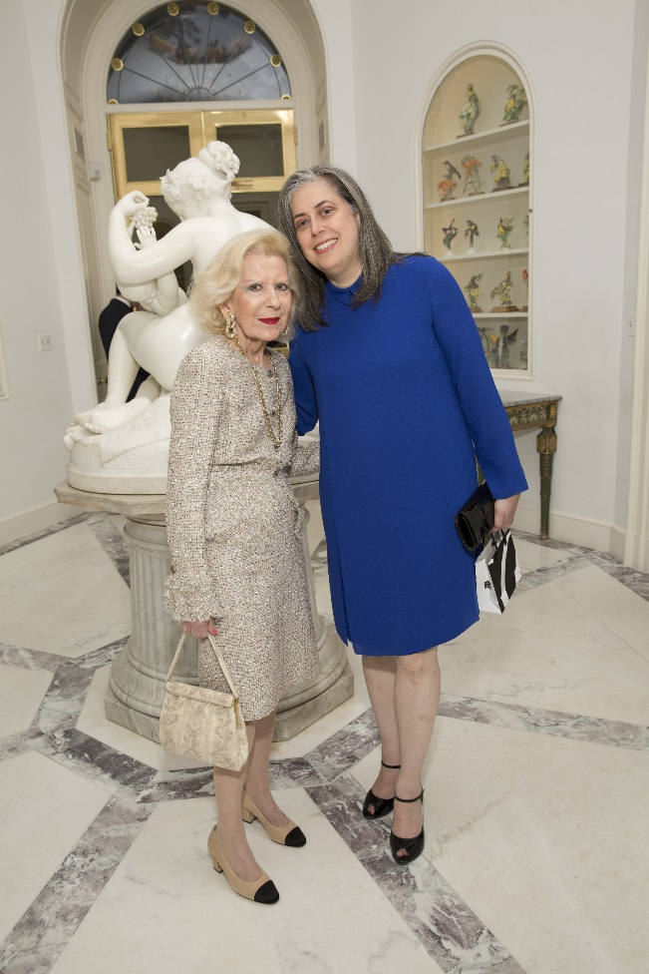
Carolyn Rosenstock-Ellis; Christine Gervais; Photo by Jenny Antill
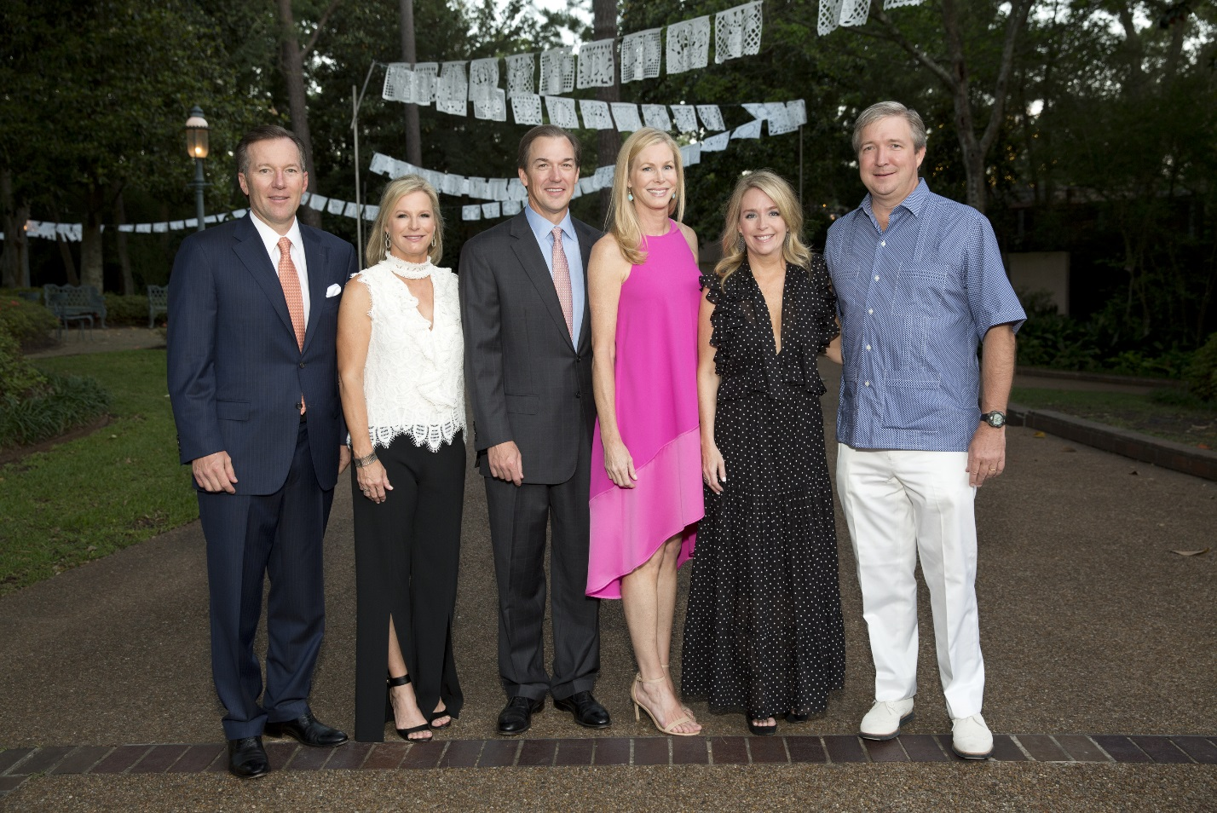
Chairmen Jeff and Stacey Henningsen; Mark and Rachel Lawrence; Angie and John Reckling; Photo by Jenny Antill
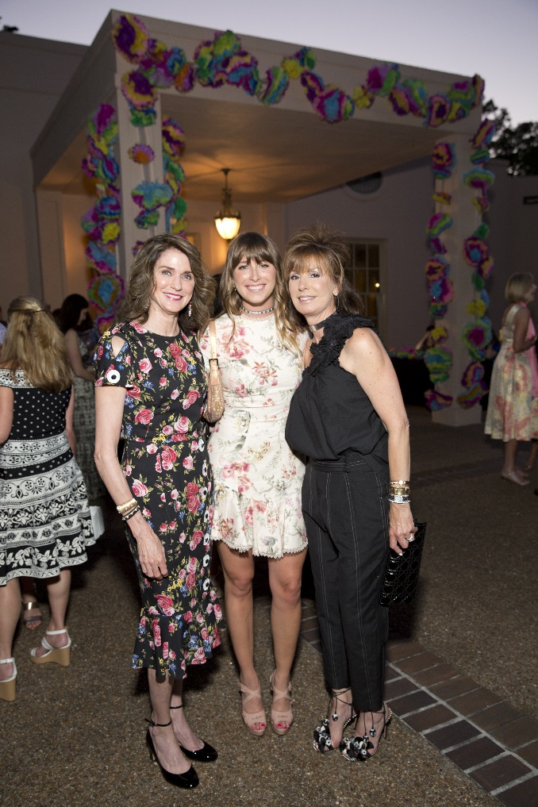
Christiana McConn; Maddie Britt; Tricia Britt; Photo by Jenny Antill
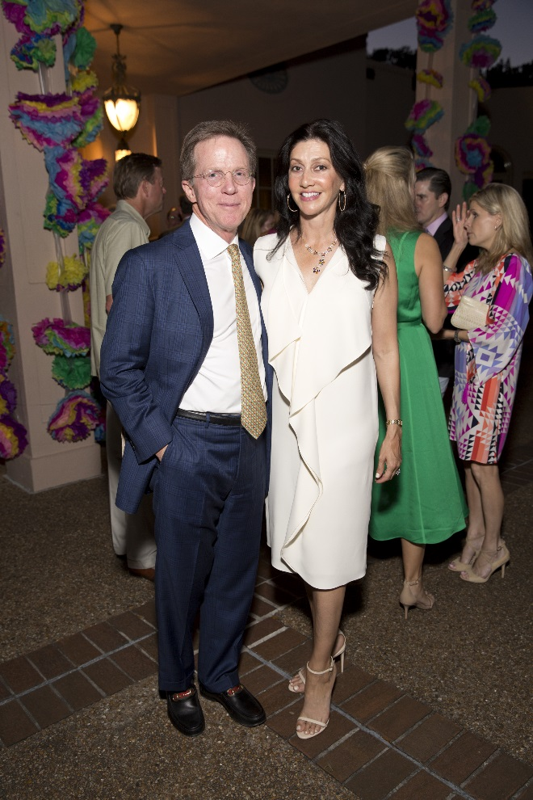
Erik and Nancy Littlejohn; Photo by Jenny Antill
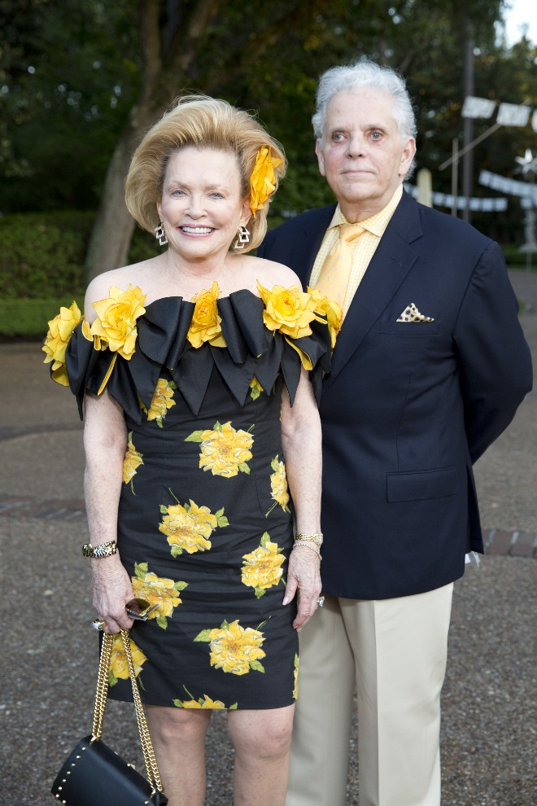
Jerry Ann Woodfin-Costa and Victor Costa; Photo by Jenny Antill
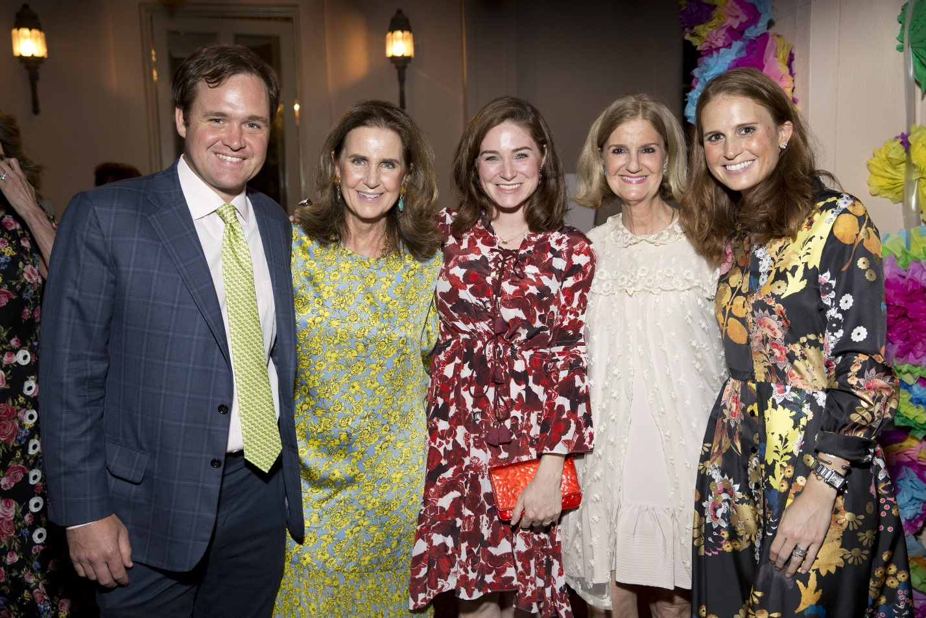
Joseph Jornayvaz; Mary Jornayvaz; Isla Jornayvaz; Sarah Solomon; Sarah Jane Howell; Photo by Jenny Antill
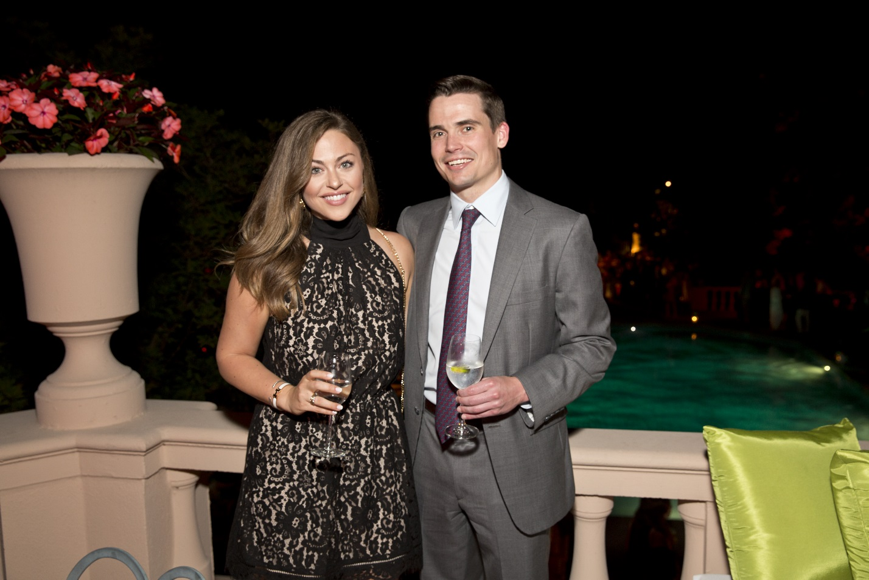
Lexi Sakowitz; Michael Marek; Photo by Jenny Antill
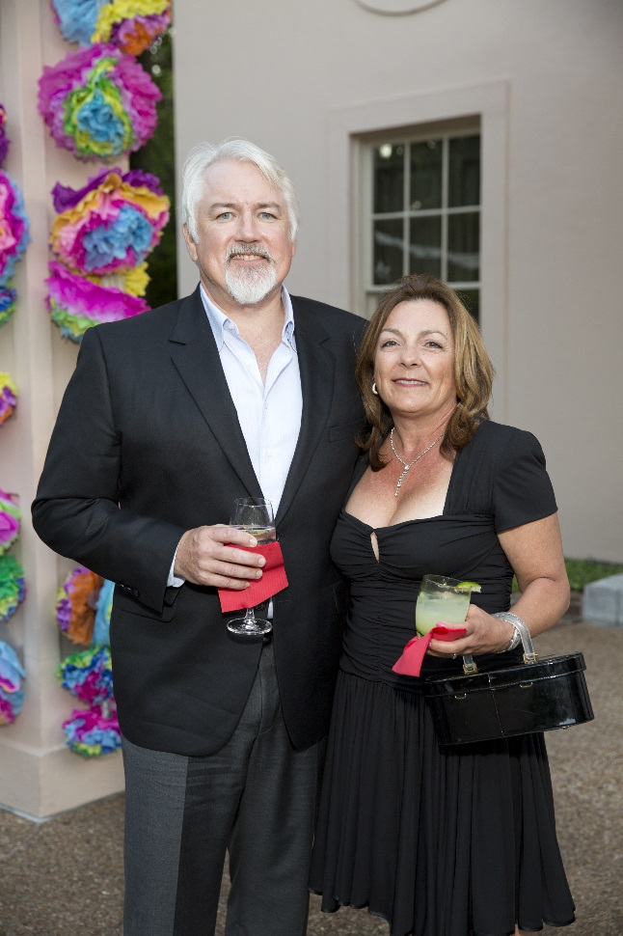
Mark and Mary Rothwell; Photo by Jenny Antill
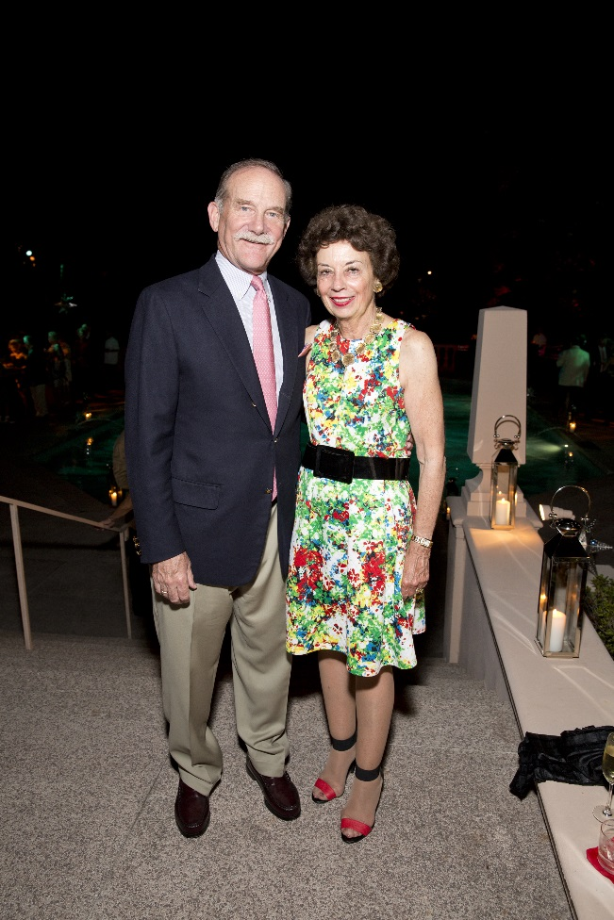
Marty and Kathy Goossen; Photo by Jenny Antill
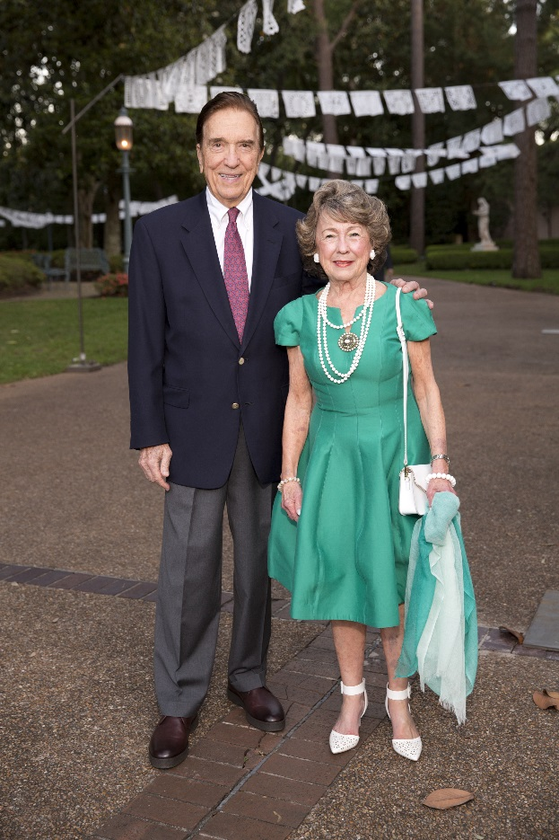
Ray Fiveash; Fran Fauntleroy; Photo by Jenny Antill
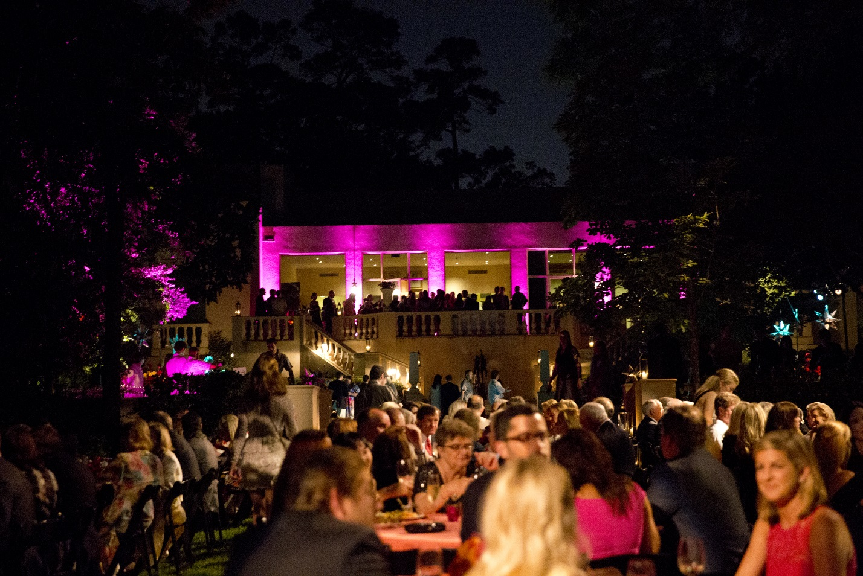
Rienzi Spring Party 2017 atmosphere; Photo by Jenny Antill (2)
Rienzi Spring Party 2017 atmosphere; Photo by Jenny Antill

