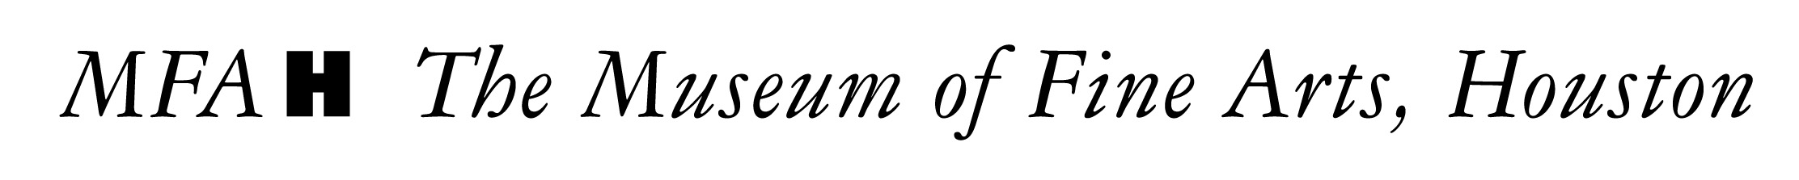

WHAT Preview and Dinner for the Exhibition Two Centuries of American Still-Life Painting: The Frank and Michelle Hevrdejs Collection

WHEN Thursday, January 12, 2017, from 7 to 10 p.m.

WHERE The Museum of Fine Arts, Houston / The Audrey Jones Beck Building

DETAILS On Thursday evening, some 120 guests gathered in the Audrey Jones Beck Building to celebrate the opening of Two Centuries of American Still-Life Painting: The Frank and Michelle Hevrdejs Collection. Trustees, donors, exhibition funders, and curators joined to kick off the opening weekend with a cocktail reception, exhibition viewing, and seated dinner.

After previewing the exhibition in the Hevrdejs galleries, guests enjoyed a meal crafted by City Kitchen, featuring baby kale salad with heirloom cauliflower, grapefruit, toasted pumpkin seeds, and red chile vinaigrette; and seared sea bass with celery root pancakes. For dessert, guests had lemon semifreddo, toasted almonds, raspberry coulis, and lemon cookies.

Gary Tinterow, director of the Museum of Fine Arts, Houston, thanked Museum trustees and exhibition donors. Frank Hevrdejs, MFAH trustee and collector, shared remarks on his collection. Bill Gerdts, author of the collections’ catalogue, also made remarks.
GUESTS Nancy and Butch Abendshein; Kathy and Marty Goossen; Bobbie Nau; Lynn Wyatt; Leslie and Brad Bucher; Jo-anne and Mike Cousins; Anne and Charles Duncan; Tom Glanville; Michelle and Frank Hevrdejs; Nancy and Rich Kinder; Carol and Michael Linn; Rodney Margolis; Laurie Morian; Sara and Bill Morgan; Tina and Joy Pyne; Macey and Harry Reasoner; Jeanie Kilroy Wilson and Wally Wilson; Cyvia and Melvyn Wolff; and Joanna and Rusty Wortham.
EXHIBIITON Two Centuries of American Still-Life Painting: The Frank and Michelle Hevrdejs Collection features over 65 works from the private, Houston-based collection of Frank and Michelle Hevrdejs.

PHOTOGRAPHER Wilson Parish

DONORS This exhibition is organized by the Museum of Fine Arts, Houston.

Lead corporate sponsor:
JPMorgan Chase & Co.

Lead foundation underwriting is provided by:
The Gordon A. Cain Foundation

Additional generous support is provided by:
Frank and Michelle Hevrdejs
Sara and Bill Morgan
Kinder Foundation
Tina and Joe Pyne

