PaperCity – Hevrdejs Opening Dinner Image Captions
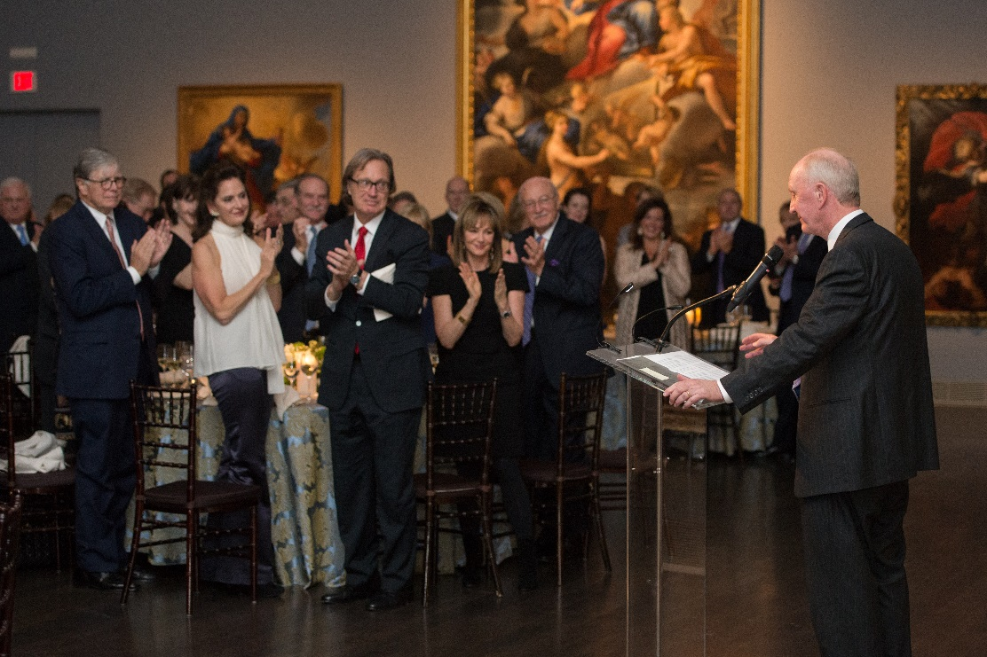
Atmosphere; Hevrdejs Opening Dinner; Photo by Wilson Parish
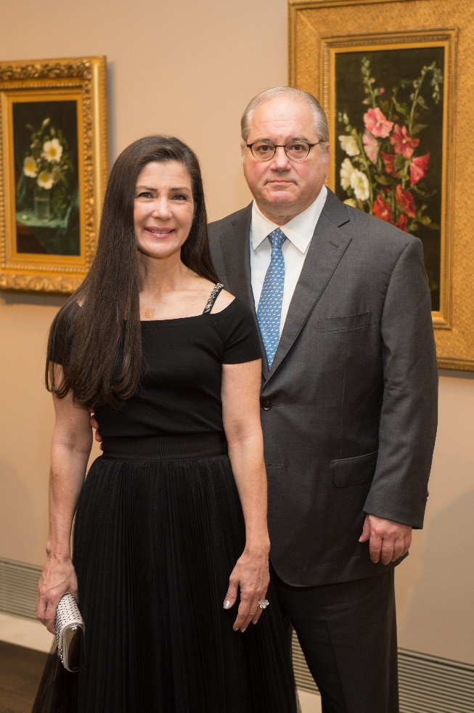
Cynthia and Tony Petrello; Photo by Wilson Parish
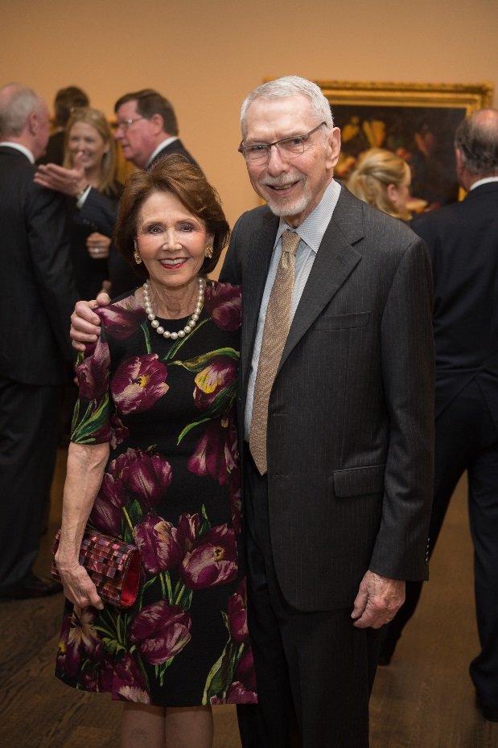
Cyvia and Melvyn Wolff; Photo by Wilson Parish
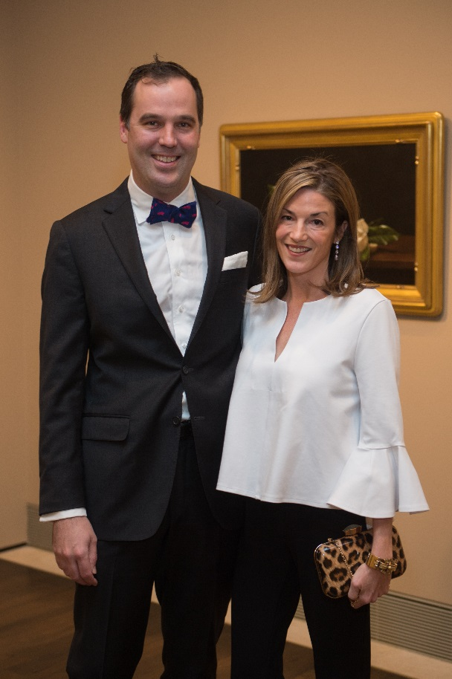
David and Sarah Larned; Photo by Wilson Parish
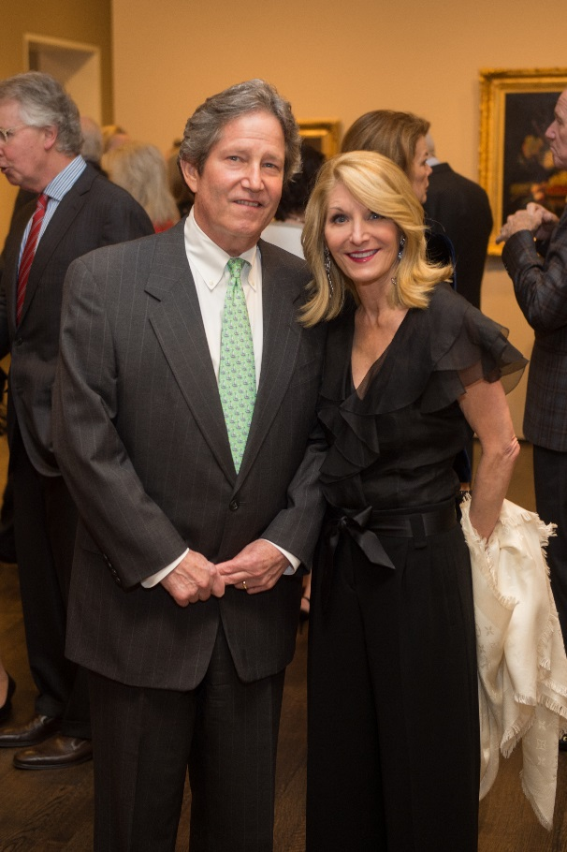
Downing and Lisa Mears; Photo by Wilson Parish
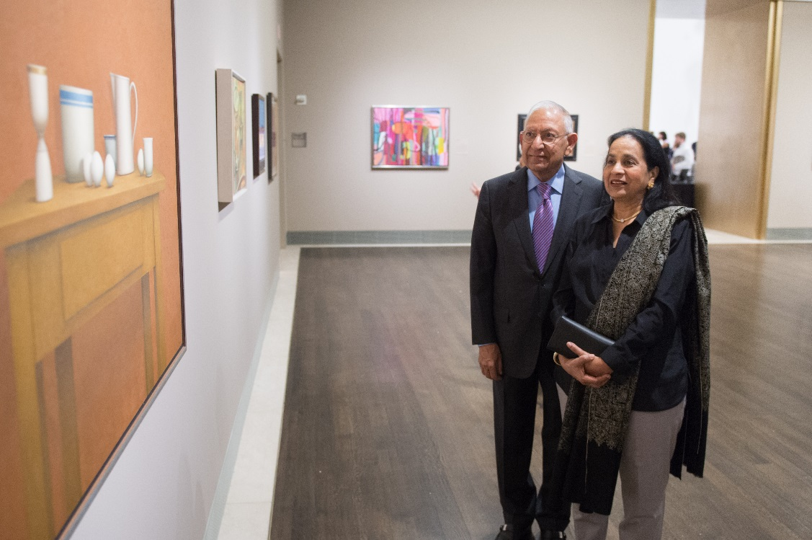
Durga and Sushila Agrawal; Photo by Wilson Parish
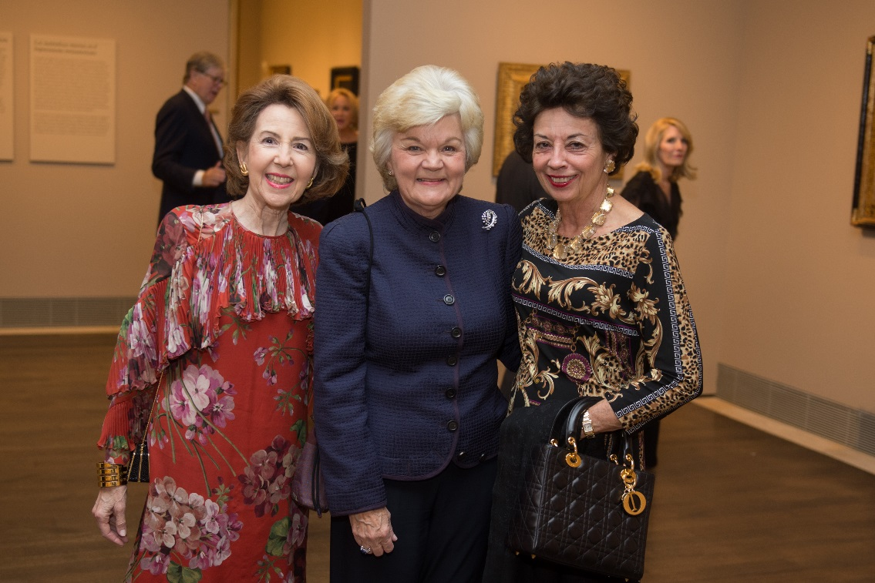
Gail Adler; Susie Glasscock; Kathy Goossen; Photo by Wilson Parish
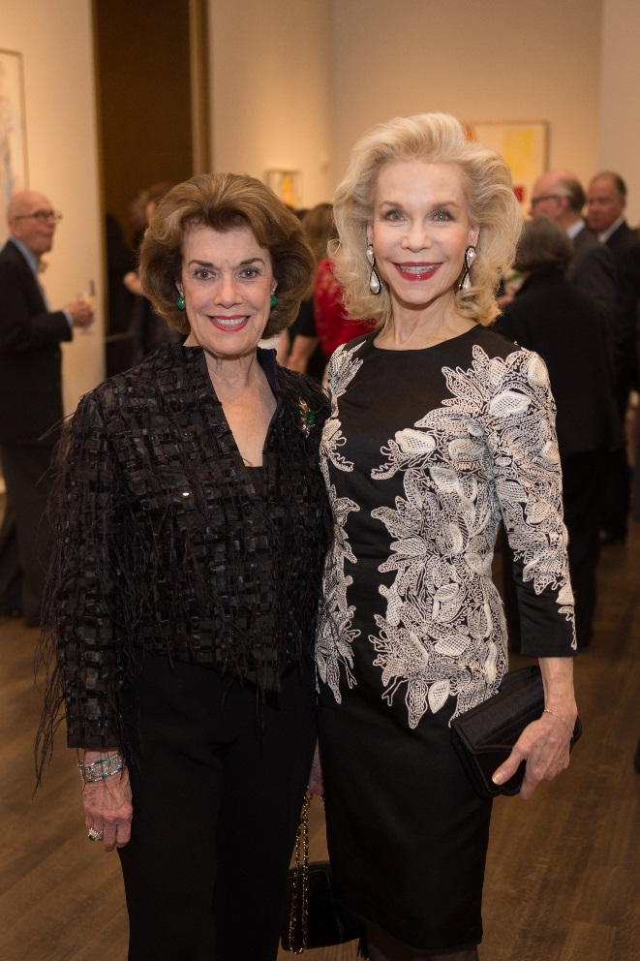
Jeanie Kilroy Wilson; Lynn Wyatt; Photo by Wilson Parish
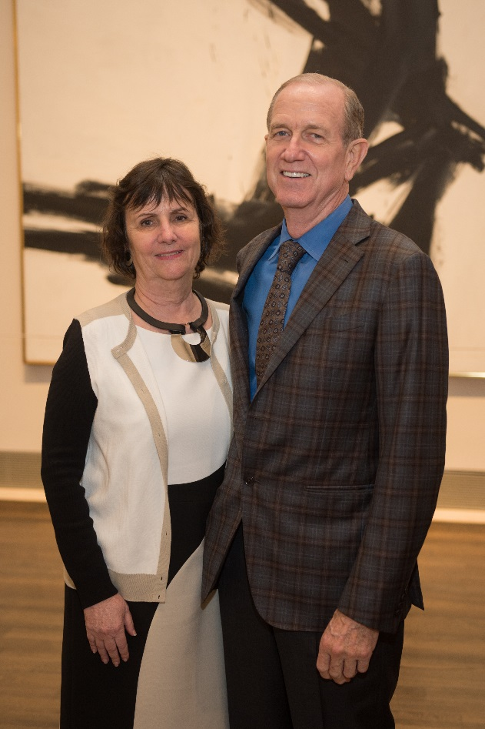
Leslie and Brad Bucher; Photo by Wilson Parish
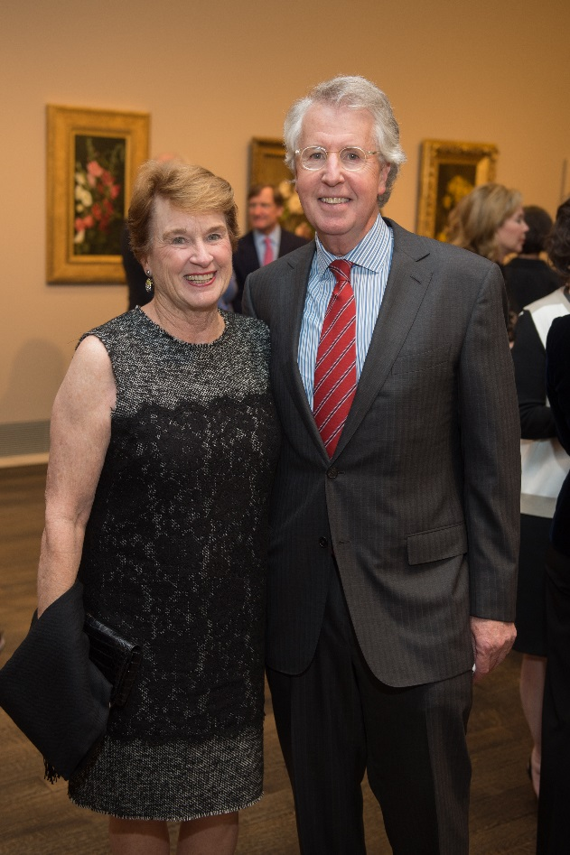
Linda and George Kelly; Photo by Wilson Parish
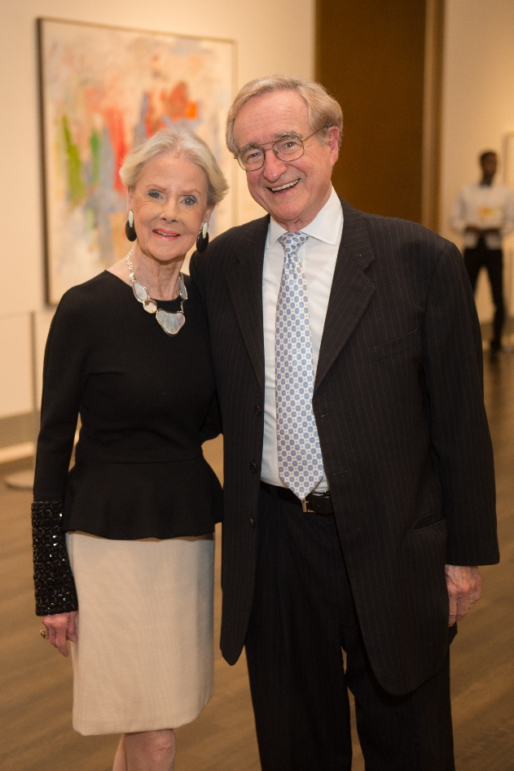
Macey and Harry Reasoner; Photo by Wilson Parish
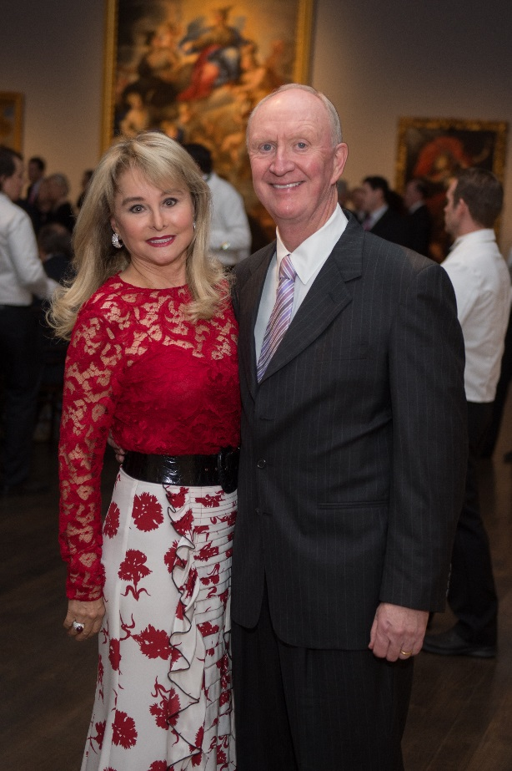
Michelle and Frank Hevrdejs; Photo by Wilson Parish
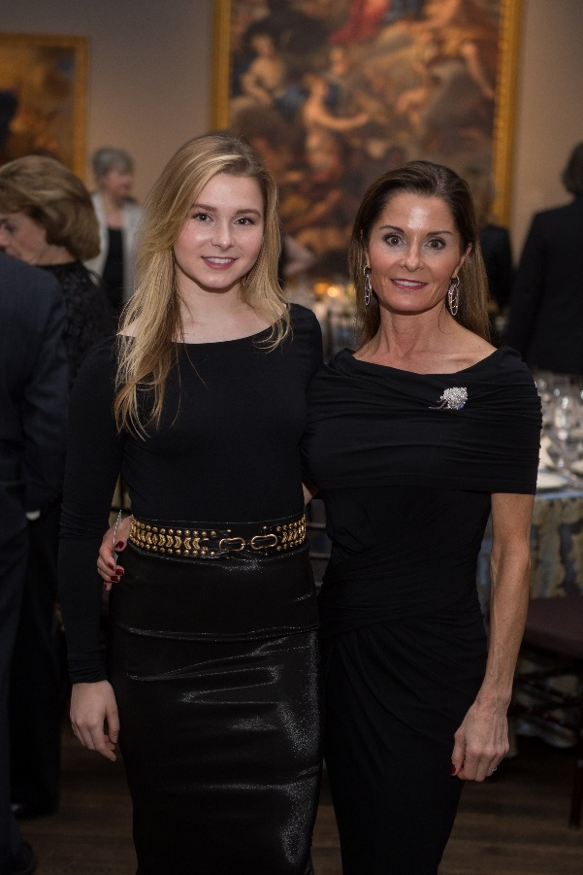
Olivia Wagner; Gabrielle Parlane; Photo by Wilson Parish
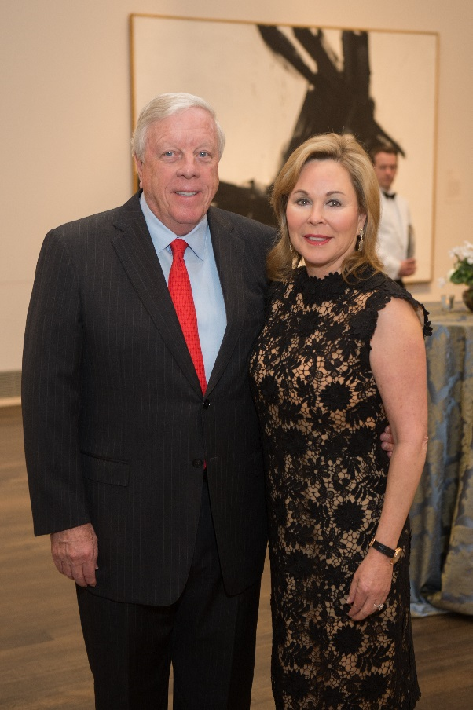
Rich and Nancy Kinder; Photo by Wilson Parish
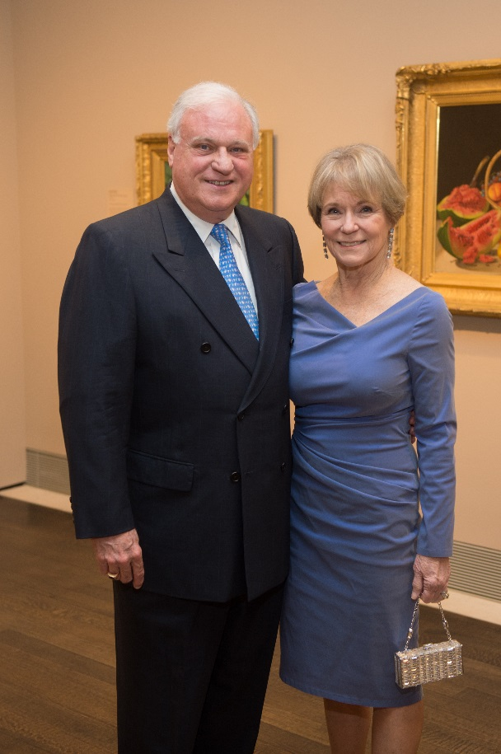
Robin and Lela Gibbs; Photo by Wilson Parish
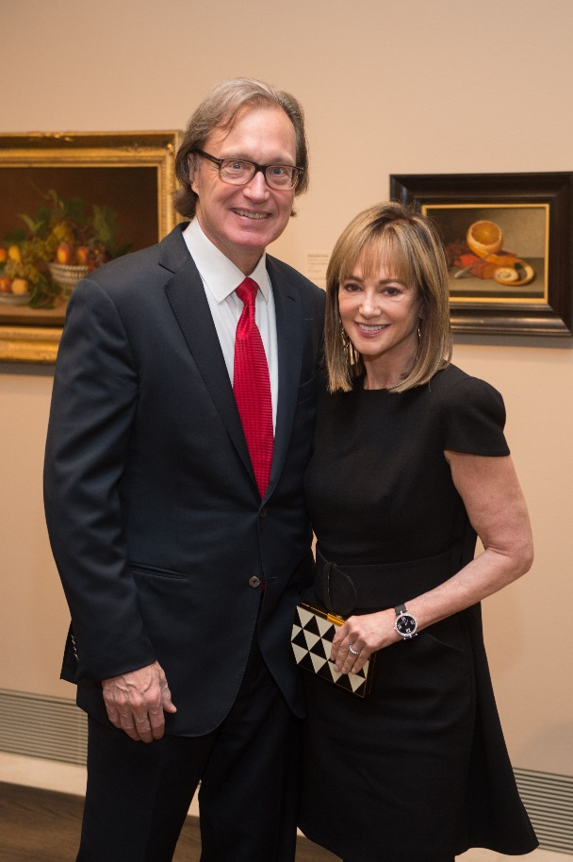
Ron Franklin; Janet Gurwitch; Photo by Wilson Parish
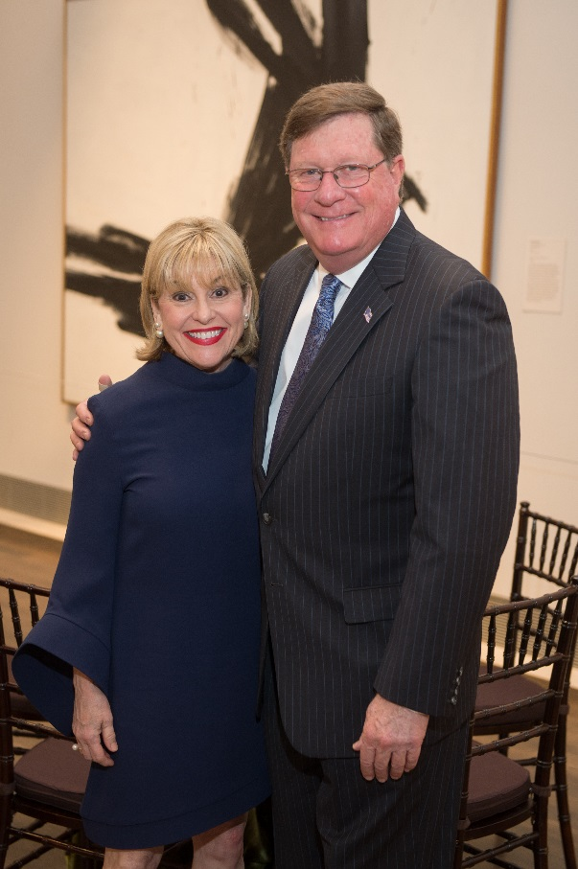
Sharyn and Jim Weaver; Photo by Wilson Parish

